Types of Poetic Meter
# Source: AI Source: Provided by: [Data Path: Persons Table -> ID Column: 1, Name_En Column: Motasem Essam] -> From: [Chatgpt (GPT-4-turbo)] on [8/2/2025]
Here’s a detailed table of the Types of Poetic Meter, organized by number of feet per line, name, and example. These are not homographs—they are metrical line classifications based on the number of metrical feet per line.

📊 Types of Poetic Meter (By Number of Feet)
# Source: AI Source: Provided by: [Data Path: Persons Table -> ID Column: 1, Name_En Column: Motasem Essam] -> From: [Chatgpt (GPT-4-turbo)] on [8/2/2025]
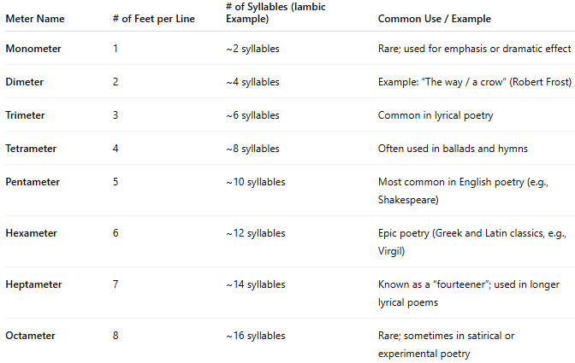
Meter Name | # of Feet per Line | # of Syllables (Iambic Example) | Common Use / Example
Monometer | 1 | ~2 syllables | Rare; used for emphasis or dramatic effect
Dimeter | 2 | ~4 syllables | Example: “The way / a crow” (Robert Frost)
Trimeter | 3 | ~6 syllables | Common in lyrical poetry
Tetrameter | 4 | ~8 syllables | Often used in ballads and hymns
Pentameter | 5 | ~10 syllables | Most common in English poetry (e.g., Shakespeare)
Hexameter | 6 | ~12 syllables | Epic poetry (Greek and Latin classics, e.g., Virgil)
Heptameter | 7 | ~14 syllables | Known as a “fourteener”; used in longer lyrical poems
Octameter | 8 | ~16 syllables | Rare; sometimes in satirical or experimental poetry

🧱 Reminder: Meter = Foot × Repetition
# Source: AI Source: Provided by: [Data Path: Persons Table -> ID Column: 1, Name_En Column: Motasem Essam] -> From: [Chatgpt (GPT-4-turbo)] on [8/2/2025]
Each line’s meter type refers to how many metrical feet are used in it.
For example, if the line has 5 iambs, it’s iambic pentameter.

🎵 Common Metrical Patterns
# Source: AI Source: Provided by: [Data Path: Persons Table -> ID Column: 1, Name_En Column: Motasem Essam] -> From: [Chatgpt (GPT-4-turbo)] on [8/2/2025]
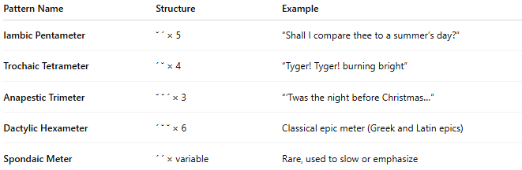
These combine foot type and line length:
Pattern Name | Structure | Example
Iambic Pentameter | ˘ ´ × 5 | “Shall I compare thee to a summer’s day?”
Trochaic Tetrameter | ´ ˘ × 4 | “Tyger! Tyger! burning bright”
Anapestic Trimeter | ˘ ˘ ´ × 3 | “’Twas the night before Christmas…”
Dactylic Hexameter | ´ ˘ ˘ × 6 | Classical epic meter (Greek and Latin epics)
Spondaic Meter | ´ ´ × variable | Rare, used to slow or emphasize

🧠 Summary
# Source: AI Source: Provided by: [Data Path: Persons Table -> ID Column: 1, Name_En Column: Motasem Essam] -> From: [Chatgpt (GPT-4-turbo)] on [8/2/2025]
- Meter = rhythmic pattern in poetry
- Defined by: type of foot + number of feet per line
- Common foot types: Iamb, Trochee, Anapest, Dactyl, Spondee
- Common meters: Iambic Pentameter, Trochaic Tetrameter, etc.

